ME 424 Engineering Design VIII

Phase 4 – Refining Design and Prototyping

**3D Printed Granular Jamming Hand**

**A Senior Report**

**Group #9:**

Melissa Indoe

Chris Kang

Sean Phelan

Maggie Serra

Chris Wallace

**Advisors:**

Robert Chang

Jennifer Field

**STEVENS INSTITUTE OF TECHNOLOGY**

Castle Point On Hudson

Hoboken NJ 07030

(February 2014)

**3D Printed Granular Jamming Hand**

# Abstract

An open-source and primarily 3D printable hand prosthesis is to be developed by a team of five Mechanical Engineering seniors in a student-driven design project. The hand will allow for performance of relatively low strength, high dexterity everyday tasks. To meet this goal, the hand prosthesis will combine the technologies of existing 3D printed hands with the use of granular jamming to maintain a firm grip at a fraction of the cost of existing prostheses. Conceptual designs have been generated and finalized. Components have been ordered and a hand prototype has been fabricated. Further designs for additional components (forearm, granular jamming pad) are being finalized and plans for future testing and development have been generated.

**Authors:** Melissa Indoe, Chris Kang, Sean Phelan, Maggie Serra, and Chris Wallace

**Advisors:** Robert Chang and Jennifer Field

**Department:** The Department of Mechanical Engineering

Contents

Abstract 2

Introduction 4

Project Objective 4

Semester Goals 4

Deliverables 4

Design/Engineering Analysis Review 5

Joint Pin Review 5

Granular Jamming Review 6

Finger Control Review 7

Design Modifications 7

Base Finger Design Modifications 7

Palm Design Modifications 8

Overall Hand Design Modifications 9

Prototype Fabrication Plan and Cost 10

Performance Testing 11

Hand Design Moving Forward 12

Comments from Phase 3 13

Gantt Chart 14

Time Table for Building/Testing 15

Budget 16

Purchased Items 16

Items with Purchase Pending 16

# Introduction

## Project Objective

The project objective is to create an open-source, high-functioning, affordable, prosthetic hand. The prosthesis will be task-oriented and able to perform simple activities requiring low strength and high dexterity. The hand should be of similar size and weight of an average human hand and look as human as possible. The prosthesis is designed for a patient who has lost an arm below the elbow. In addition to designing a fabricating a hand, the modifications will be made for an existing forearm housing to hold the electronics and components for the prosthetic. By use of open-source software, inexpensive materials and parts, and simple assembly, this design will allow other users to take the prosthetic and make whatever modifications they desire, whether for control, or aesthetics. Several major issues in this project include maintaining dexterity of the fingers, device durability, and keeping the device affordable and the parts easily attainable.

There are several goals for the prosthetic hand. It will be able to pick up, hold, and put down objects of various sizes and shapes. It will also open and close different sized doors, from knobs to refrigerators. The prosthesis will be able to make simple hand gestures, including “thumbs up” and pointing, and will also be able to use a computer mouse. While the hand may not be complex enough for the use of traditional utensils, it will be able to hold occupational therapy tools, including cutlery and writing utensils. If the prosthesis can complete most of these tasks, the project will be a success and can prove very useful in day-to-day life.

## Semester Goals

There are a few goals for this semester. The primary goal is to have a finished model of the prosthesis and have a fabricated a working prototype. A secondary goal is to finish and update a website documenting the progression of the project and downloadable models files and code, as well as documenting group progress via reports and presentations.

## Deliverables

This senior design project will be completed during the current semester. Several deadlines for project reports have been put forth by the professor, and the group has created its own deliverables for these deadlines, to ensure that steady progress is made until the project’s completion in May. This semester will contain Phases 4, 5, and 6 of our project. The deadlines provided to us are shown below:

|  |  |  |
| --- | --- | --- |
|  | **Written Report** | **Oral Report** |
| **Phase 4** | February 11 | February 13 |
| **Phase 5** | No Written Report | March 18 |
| **Phase 6** | May 6 | May 8 |

During Phase 4 the team has accomplished many goals. The team has ordered most of the large project parts, 3D printed the first complete hand, started programming for the Arduino Uno, started editing the forearm model, started development methods for granular jamming production, and continued to develop the project website.

In Phase 5, the team will test and iterate the hand as well as the granular jamming system, finalizing both. Programming the Arduino will be mostly completed except for necessary modifications as testing continues (adjusting speed, sensor sensitivity, etc). As parts are delivered, the project will be assembled. The forearm model will be completed and prototyped. The website will be completed by the end of Phase 5, as required by the professor.

In Phase 6, the final testing will be completed and a final prosthesis will be created. The final design of the forearm will be generated, and the arm assembled. Most of the time during this phase will be devoted to troubleshooting the various small problems that crop up when a design is first built. A poster will be constructed for Senior Design Day being held on April 30, 2014. A final presentation will be given on May 8, 2014. The website will be updated with all progress associated with the project, and the final result.

# Design/Engineering Analysis Review

The 3D printed granular jamming prosthetic hand has several components that are essential for finger movements, granular jamming, and force transfer from motors to fingers. The hand will be printed whole as a non assembly unit, and the forearm case will be printed upon completion of the forearm CAD model, which contains the mounts for the motors, vacuum, battery, and Arduino (which is scheduled for first prototyping in Phase 5 and completion in Phase 6).

## Joint Pin Review

Force testing in SolidWorks (completed during Phase 2) showed that the hand could be printed as a non-assembly model with cylindrical joint pins. While the plastic pins are more fragile than metal pins, it was shown that they were still capable of withstanding forces under usual working conditions (i.e. when the hand is being run under the power of the motors). More importantly, it was shown that any significant force actually pushed the finger segments backward into their respective hinges, taking the force off the pins and exerting it as a crushing force between hinge segments. Therefore the pins will not break first in a failure scenario, instead the hinges will crush and deform together. This was good news because it meant that the hand could be printed in one piece as a non-assembly model. This saves on tools and assembly time for the user, and makes printing and assembling the hand much less daunting.

The second problem with printed joint pins is that they are hard to manufacture via 3D printing, since it requires the print to occur in midair, leading to unavoidable warping. However, manufacturability tests were run during Phases 3 and 4, and showed that the cylindrical joint pins, while not ideal, were functional when printed in these conditions. The solution proposed by the team to eliminate the effects of this warping was to press fit small bearings within the finger joints, decreasing friction and forcing the pins into the correct shape. This was a major point of contention with members of the panel, since so much effort was being made to make the plastic pins functional, rather than just using simpler metal pins. Therefore the concept was revisited in the current phase and the cylindrical pins were changed out for conical ones, which include far less severe overhangs due to the fact that they “step” upward in a gradient. This eliminates any need for bearings and makes the hand much easier to manufacture.

## Granular Jamming Review

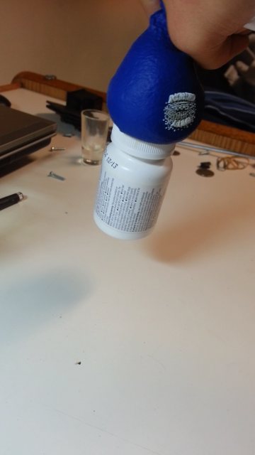The 3D printed granular jamming hand also of course utilizes the concept of granular jamming, where small particles in a flexible container act as a fluid when loosely packed, but become rigid when the granules are tightly packed together. Applying granular jamming to the hand makes the hand capable of picking up relatively small objects, which would otherwise be difficult for the fingers (which have fairly low dexterity). Picking up objects is done by pressing a pad on the object, jamming the granules by using a vacuum to remove air from the pad, and then lifting the object with the pad.

Figure 1: Demonstration of granular jamming. Here a balloon full of coffee grounds is used to lift a pill bottle.

The team previously found via research that 75 kPa was sufficient to pick up objects, and sourced a pump with this pressure differential. They also found the diameter size tubing that would be needed to pick up an object in a timely manner (about half a second). This pump and tubing is currently being purchased during phase 4.

It was decided that the pump will be controlled by either manually starting and stopping when a switch is pressed on the forearm, or by automatically running when the fingers have made contact with an object (this will depend on whether testing shows that doing this will actually improve grasping grip). Ultimately it can be controlled via Bluetooth commands but this functionality will likely not be created by the team (though they will include support for other to develop this functionality).

The materials used for the granular jamming applications are coffee grounds (determined via research to be the most effective granular jamming material), foam that will act as a filter between vacuum and coffee grounds, and latex for the housing. Previous research showed that to ensure the grip of the granular jamming pad, the object size must not be bigger that 75% of gripper radius. The palm of the designed hand is a trapezoidal shape with a surface area of about 54.8 cm2. This size should be more than suitable for picking up various small objects.

Currently a granular jamming pad model has been generated to match the palm shape. This model will be used to generate a mold for the soft latex housing. Creation of the first latex prototype should occur during Phase 5, with all granular jamming design completed near the beginning of Phase 6, when the pad will be ready to implement with the rest of the hand.

## Finger Control Review

Finger motion will be generated via fishing line tied to the tips of the fingers and reeled in by servo motors. To contract the fingers and use the hand, the servos will be commanded to turn on, but because the servos cannot sense contact with an object, they will continue to run when the fingers cannot move and eventually burn out.

To account for this issue, a system to sense contact will be implemented. The servos will be mounted so that they can slide. Each motor will have fishing line going down towards a finger, and a spring pushing them backward in the slide. A magnet will be attached to each motor and a Hall Effect sensor, mounted on the housing, will measure its magnetic field. As the finger contacts an object, that object will resist the finger’s closing. As a result the line will begin to offer more resistance to getting reeled in by the motor. Because the motor is free to slide, it begins to pull itself forward, toward the hand. This changes the magnetic field measured by the Hall Effect sensor. This change in voltage from the sensor will tell the Arduino to command that servo to hold its position and stop the finger from contracting, keeping the servo from burning out. This setup allows the hand to modulate pressure in an accurate and inexpensive way, while having absolutely no electronic components in the hand itself.

This control system will be created during Phase 5, along with the completion of the forearm model. Most of Phase 6 will be devoted to getting it to work consistently and correctly, along with other design adjustments and troubleshooting.

# Design Modifications

A fully functional finger design and a very basic palm design were completed at the end of Phase 3. However, the finger design still could be modified for easier production, so changes were made to make the hand more feasible to 3D print. The palm design was also heavily modified to make it ready for manufacture. Fingers were also made realistic lengths. After all of these modifications, a prototype was manufactured.

## Base Finger Design Modifications

A fully functional base finger design was completed by the end of Phase 3. However, since then, several modifications were added to the design in order to make the finger even easier to print and cable. The changes included redesigned and repositioned wire guides, conical joint pins, reduced height, and smaller tolerances.

The wire guides were redesigned because although the previous design functioned well, it featured relatively large overhangs where the current wire guides, round pins, bridged across the center of the finger. The new design has fewer guides (since some of the existing guides turned out to be unnecessary), and the guides are now flat faces with a hole for wire. This design eliminates overhangs, since the hole is round and therefore graduates up to the bridge in the center. The guides were also made thinner and moved downward, which increased the finger’s range of motion (since before there was a small amount of friction within the joints). This change in wire guides was also done to make threading cable more intuitive. Instead of the pins, where users could be unsure of which pins to go over, which to go under, and which to ignore, they are presented with the plates with holes, which is far more intuitive. You can simply thread the cable through the four holes and the finger will work correctly, rather than the eight pins in the old design.

The joint pins were changed from a cylindrical to a conical design for the same reasons as the change in cable guides. In the original design, the printer needed to make a large overhang in one pass, which is very prone to drooping down and bridging to the joint hole. By starting the pins with a large base and tapering them to point, the printer now only needs to make many small overhangs, each stacked on top of the other, in a graduation. This method is far less prone to bridging. Additionally, as long as the overhang angle is kept under 45 degrees, the pins will not deform in a standard hobbyist 3D printer.

The last change was of the finger itself. The heights of the fingers were reduced by 4mm to make them slightly less blocky and more realistic. Finally, the tolerances between joints were significantly lowered. This was because the joints in the previous base finger were fairly loose and one of the TAs suggested lowering the tolerance to a standard accepted level for printed revolute joints (.02 inches) to decrease this looseness.

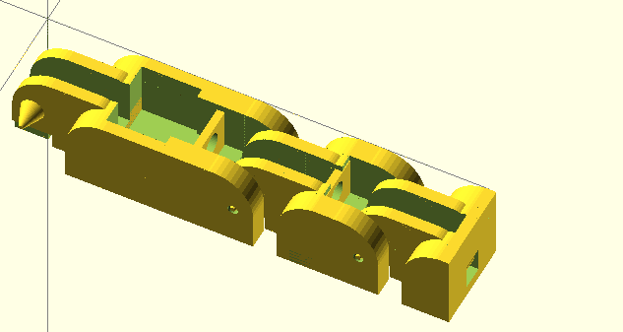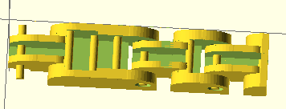

Figure 2: Previous finger iteration (left) with pin-shaped cable guides, round joint pins, and large tolerances, and new finger iteration (right) with redesigned cable guides, conical pins, and lower tolerance.

## Palm Design Modifications

At the end of Phase 3, a palm design had been completed with four low-level cable guides running along the palm, toward the wrist. This palm design also had no guard to keep the granular jamming pad from interfering with the thumb. It also did not have a mounting point for the forearm, and the walls were rather thick, making the palm heavier and use more plastic.

The palm was therefore heavily modified during Phase 4. These changes include taller and more complete cable guides, a mounting point for the forearm, a guard for the thumb, and thinner sides. The fingers were also moved further apart, to prevent bridging, and the thumb was moved away from the side of the palm for the same reason.

These new, taller, cable guides were very important since the original cable guides were very low to the palm surface. This positioning forces the cables downward and decreases their leverage on the fingers, taking more energy to curl the hand inward, or worse, possibly creating a toggle point and stopping motion before the finger is fully bent. OpenSCAD does not support a sweep or loft feature, so small gaps were left in between these cable guides where their direction was changed. This is however not an issue because the granular jamming pad is not so fluid that it will fill in these small gaps.

Other smaller changes were made. A forearm mounting point was included. It consists of a flat plate with holes for four plastic screws. The holes are slightly larger than screw diameter, making it possible to drop them through the palm wrist attachment and thread into the forearm, ensuring a tight fit with no gaps. A thumb guard was also added. It exists so that the granular jamming pad cannot spill over the side of the palm and create friction against the side of the thumb. This ensures a good range of motion for the thumb and prevents unnecessary wear on the granular jamming pad. Finally, the fingers and thumb were spaced out more to prevent the plastic from bridging between fingers or between thumb and palm and impeding motion. The final palm design was as follows.

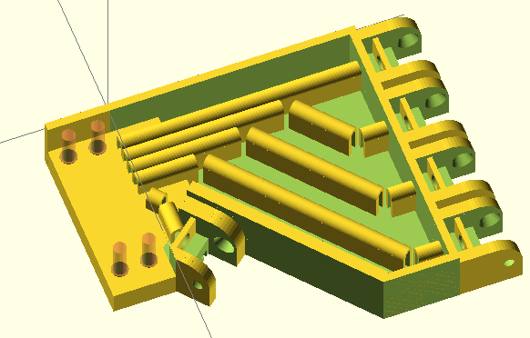 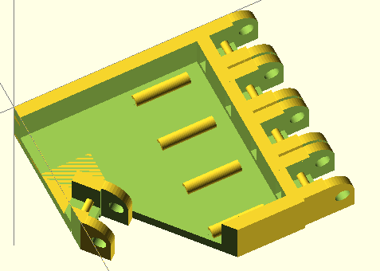

Figure 3: Previous palm iteration (left) with low level cable guides, no forearm mount, and no thumb guard. Current palm iteration (right) with and more complete cable guides, a forearm mount, and a thumb guard.

## Overall Hand Design Modifications

At the conclusion of Phase 3, a hand design had been completed with all equally sized fingers. For Phase 4, finger length was adjusted to more closely match the proportions of human fingers. Each finger, with the exception of the pinky, is exactly the length of the average human equivalent. The pinky is about 10cm longer than average due to the hinge design. This is because if the finger were any shorter the hinges would overlap and the finger would be unable to bend.

# Prototype Fabrication Plan and Cost

Figure 4: Previous (left) and current (right) hand iterations. Current hand iteration includes updated palm, updated base finger design, and realistic finger lengths.

The first complete hand prototype was printed on Thursday, February 6th. All of the 3D printed parts will be produced using the 3D printing facilities at Carnegie lab. The majority of the non-printable parts have already been ordered. Total cost thus far has been $138, well within budget, with the ordered parts coming at their budget ($131 has been spent on non-printable parts so far), and the hand itself using 150 cm3 of ABS plastic, costing about $7.05 in material.

Future plans for fabrication include slightly modifying the hand design and printing the final iteration (which should occur within the next 1-2 weeks), then finalizing and printing the forearm design (scheduled for completion within about a month) and then finally assembling the parts and writing some basic programs for grips, etc.

The granular jamming pad has been designed and production of the pad will begin within the next 1-2 weeks. The current plan for granular jamming pad production is to 3D print a mold out of ABS and then use it to slip-cast latex. Now that the pad design is complete it should be trivial to use it to make two mold halves and an inner mold surface.

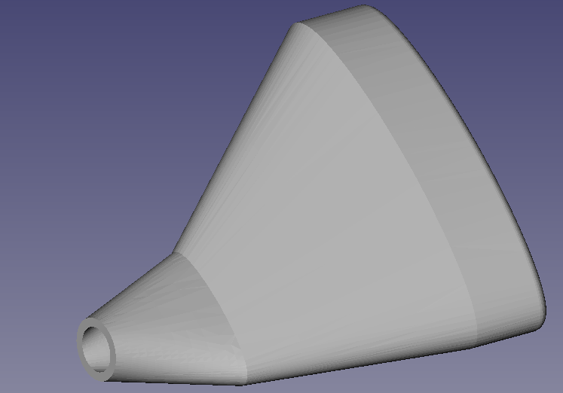

Figure 5: Granular jamming pad design

## Performance Testing

The first iteration of the complete hand was a moderate success. Most parts of the hand worked successfully, though some aspects need to be modified in the future.

The redesigned fingers were all individually successful. The new cable guides increased range of motion, printed successfully, and worked exactly as expected, such that pulling on the cable produced full motion of the digit. The base knuckle, the joint between the finger and palm, also worked successfully. This is notable because prior to manufacture of the hand as a whole, the base joint had never been tested (only the top two joints were tested, with the base hinge printed without its mate). Additionally, all the fingers worked at all their different respective lengths. This is another element of the project that had not yet been tested, and has proven successful. The hand is also proportionate to a real, human hand.

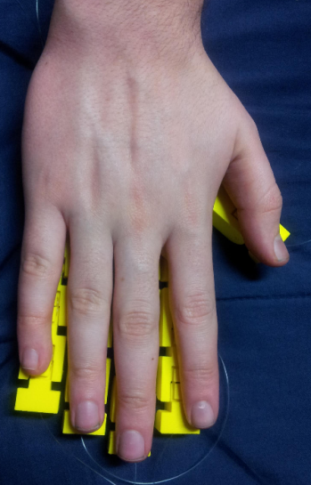

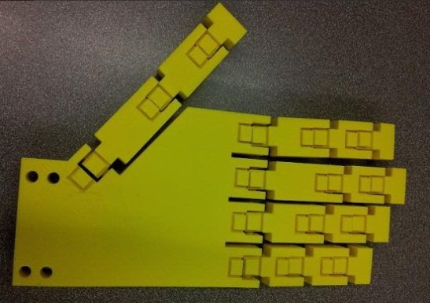

Figure 6: Hand model compared to a human hand.

The only major problem with the fingers was that the tolerance suggested by the TA was actually slightly too small. This caused the sides of the hinge interior to bridge to the inside of the exterior portion of the hinges. The same tolerance was also used however for the revolute portions of the joints (between the joint pins and their housings), where it worked very well and completely eliminated rattling, as well as removing the necessity for bearings. The bridging between hinges was fairly easy to break via forcing the fingers through their range of motion, however there is a great deal of internal friction in the joints still, and looking inside them reveals some jagged, broken off webbing between the joint sections. Due to this friction, it also takes more tension than necessary to pull in the fingers. The solution to this is simply to slightly raise the tolerance for the next print iteration. Despite the fact that it had been set to an accepted value, 3D printing is very prone to changes in humidity, temperature, etc, and this larger tolerance will be used in the future.

The palm printed correctly except for one fairly large error. The cable guides for the palm actually hover above the palm surface, meaning that any cable guides not directly attached to palm walls actually broke off. Some inspection showed that this was a problem with the original model, however, and that it hadn’t been noticed because the gap was blocked by other features in OpenSCAD views. This problem has been immediately rectified for future designs. Printing the palm also made it clear that the wire guides only needed to be about half their original height, which is good news because it means that they can be made shorter in the next iteration, making more room for the granular jamming pad (allowing it to be “deeper” means that it will have greatly increased gripping ability). Aside from these two minor problems, the palm is complete.

The hand design does have one major issue, however. With the current orientation of the thumb, motion is actually almost exactly opposite to motion of a real, human thumb. This means that the angle of thumb attachment must be revisited (attaching it at the opposite angle would ensure realistic range of motion, but look very unlike a human hand when resting), and possibly a minor redesign must be performed for the thumb prior to Phase 5. However, this is the only major problem with the hand design, meaning that design is nearly complete and the bulk of focus can now be shifted to the forearm and granular jamming components.

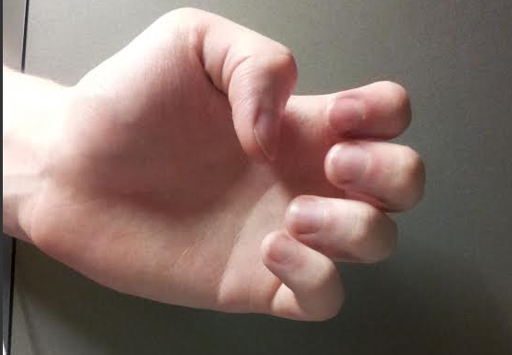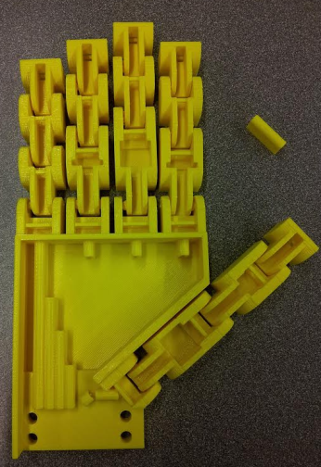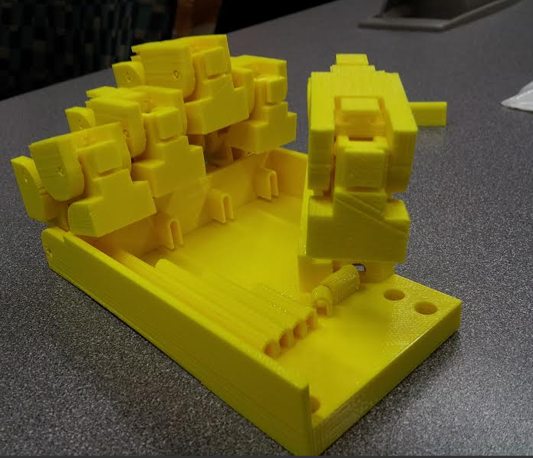

Figure 7: Printed hand (left), printed hand displaying range of motion (middle), and actual hand displaying range of motion (right). Notice the missing joint guides, and the recovered joint guide to the top right of the first photo. Note also how the finger motion is correct, but the thumb on the printed hand bends downward, toward the wrist, while the human hand bends upward, toward the fingers.

## Hand Design Moving Forward

The wire guide placement issue that was causing the wire guides to print detached from the palm has already been rectified. Additionally plastic thickness at the forearm attachment point has been reduced. This reduces the weight of the hand and the amount of plastic necessary for manufacture.

The next step with the hand design is to redesign the wire guides. Testing showed that they could work effectively at about half their current height, and that making them shorter would greatly increase the available space for the granular jamming pad. Additionally they will also be changed in shape to a solid post with a circular hole, rather than a hollow shape. This will make it much easier to run wires through the guides (since as it is they can get caught the edge of the forearm mount).





Figure 8: Current (left) and proposed (right) wire guide cross sections.

The final (and most involved), step will be to redesign the thumb. The angle of attachment can be mirrored, creating realistic motion but a very unrealistic resting position, or the entire concept of designing the thumb as a finger can be revisited. It is possible that it may require a different style of joint in order to bend correctly from a realistic resting position. This will be the most difficult and time-consuming element of updating hand design.



**Figure 9: The simplest possible solution to thumb issues. This orientation would create an unrealistic resting position but realistic motion.**

# Comments from Phase 3

Very few comments were made by the panel during Phase 3. The most notable of them was a verbal comment from a panel member stating that he did not like that the team was using many off the shelf parts. He amended this comment by saying that upon further thought, it made sense to use off the shelf parts because the nature of the prosthesis is to make it easily accessible to the public.

However, a lot of comments about the joint pins were made during previous phases. The first was in regard to the use of bearings. A few panel members did not like that the team was planning on using bearings around the joint pins. This comment has now been addressed by the fact that the joint pins have been updated and will no longer need assistance from bearings. The other comment about the joint pins was an issue with manufacturability. Since the pins have been modified to a conical shape, the issue becomes much less of a problem.

# Gantt Chart

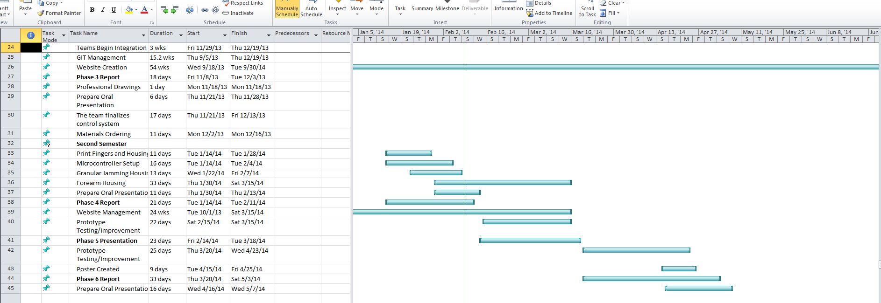

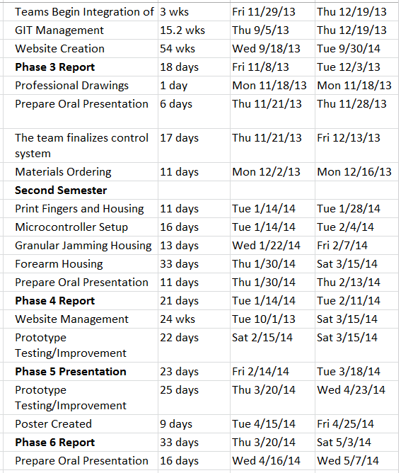

# Time Table for Building/Testing

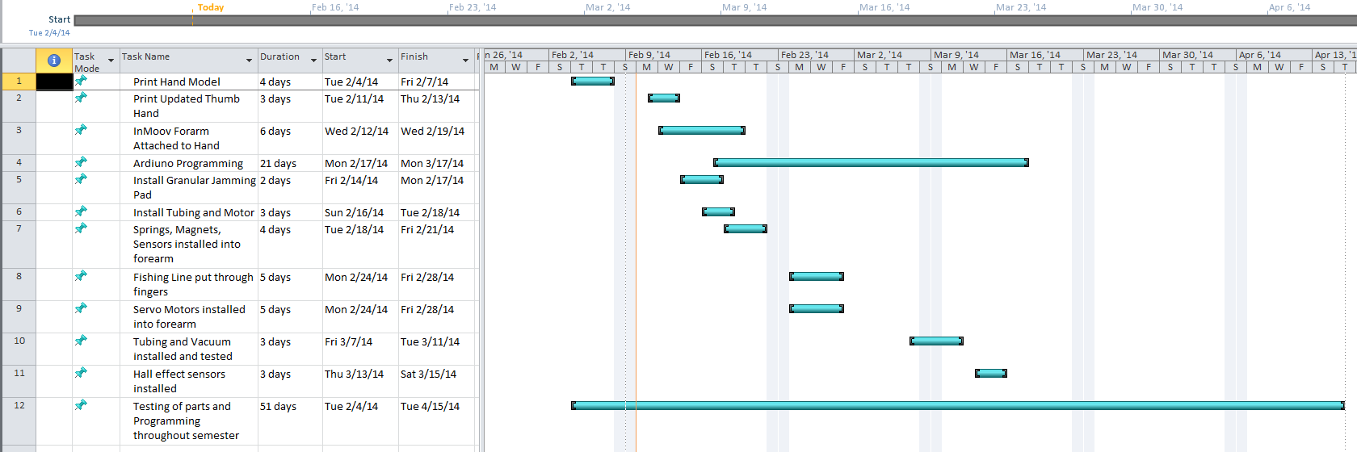

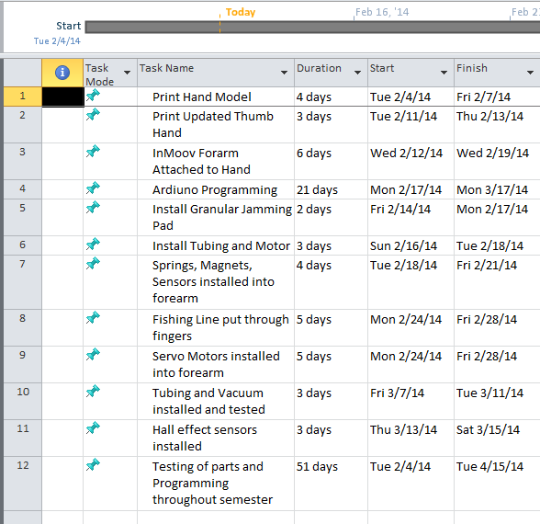

# Budget

## Purchased Items

|  |  |  |  |
| --- | --- | --- | --- |
| **Quantity** | **Part** | **Price Per Unit** | **Total Price** |
| 1 | Arduino Uno board REV 3 | $28.57 | $28.57 |
| 4 | Hall Effect Sensors | $1.64 | $6.56 |
| 1 | I/O expansion Shield V7 | $15.99 | 1$5.99 |
| 2 | Relay Module V2 | $7.80 | $15.60 |
| 4 | MG995 Metal Servo | $9.52 | $38.08 |
| 1 | 12 V Expandable Battery | $25.99 | $25.99 |
|  |  | **Total Cost:** | **$130.79** |

## Items with Purchase Pending

## 

|  |  |  |  |
| --- | --- | --- | --- |
| **Quantity** | **Part** | **Price Per Unit** | **Total Price** |
| 1 | 100 piece Cylinder Magnets | $3.99 | $3.99 |
| 5 | Steel Helical Compression Spring | $4.99 | $24.95 |
| 1 | 25 1/4 Thick Stainless Steel Screws | $6.49 | $6.49 |
| 1 | 6' Silicone Air Line Tubing | $3.33 | $3.33 |
| 1 | Position Pneumatic Valve | $39.95 | $39.95 |
| 1 | 1 Pint Platex Mold Latex | $36.00 | $36.00 |
| 1 | Micro Brushless Air Vacuum Pump | $52.25 | $52.25 |
|  |  | **Total:** | **$166.96** |